**Capstone Project – Programs file name & output**

* **Capstone Project:**

**User :**

**private** int id; //primary key , auto increment

**private** String name;

**private** String address;

**BankAccount :**

**private** int id; //primary key , auto increment

**private** String accountNumber;

**private** String accountType; //savings,current etc.

**private int userId ;**

The microservices to be created based on database per microservices philosophy.

b) There will CRUD end points for both of the microservices , however account details could also be updated through user microservices (account details could also be maintained separately through its own rest end points).

c) All the user endpoints will be doen through /user end point and bank accounts could be done through /bank end points.

d) Create a UserVO or UserDTO for passing the information that will contain both User and BankAccount information. It will Look like

Class UserDTO

{

**private** int id;

**private** String name;

**private** String address;

List<BankAccountDTO> listBankAccounts.

}

BankAccountDTO willl be a replica of BankAccount Entity except the annotations.

e) For inter microservice communication i.e from USER to Bank Account microservices to be called for CRUD , use openFeign or RestTemplate.

f) Use Service Discovery and API Gateway.

g) Provide postman screenshot hitting the urls from API gateway.

h) Provide code base for all microservices, service discovery and api gatweay.

**Project Folder Name:**

**Capstone Project -> eureka-server.zip, api-gateway.zip, user-service.zip, bank-account-service.zip**

**Output:**

* **Create user details and bank account details for that particular user**

**url:** [**http://localhost:8085/user**](http://localhost:8085/user)

**method: POST**

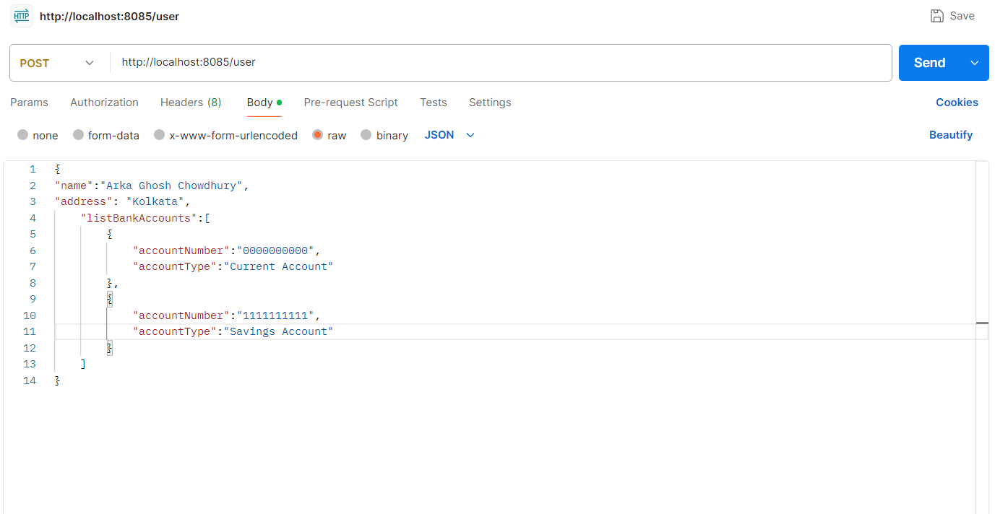

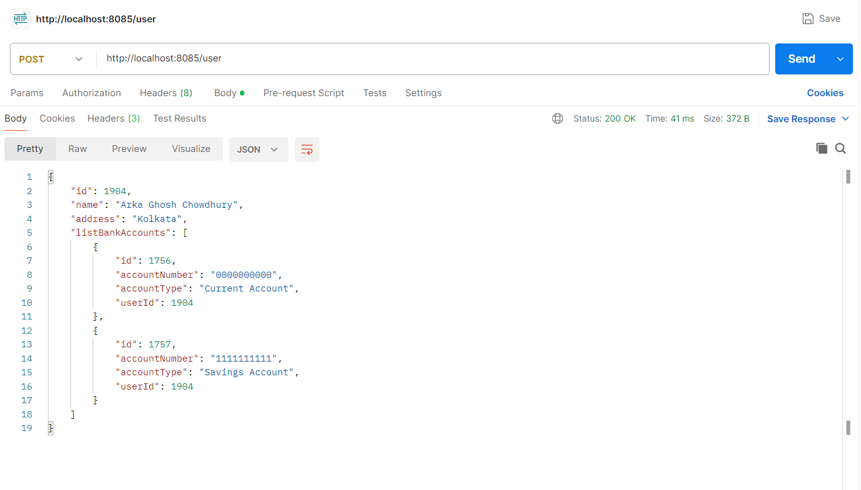

**Tables:**

* **USERS**

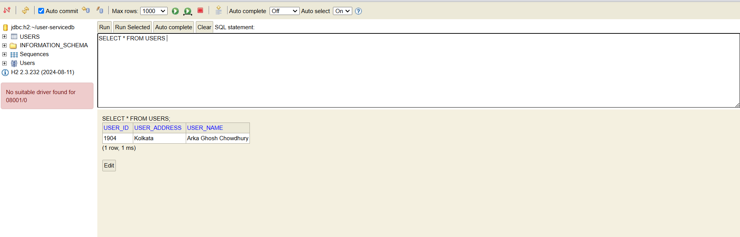

* **BANK_ACCOUNT_DEATILS**

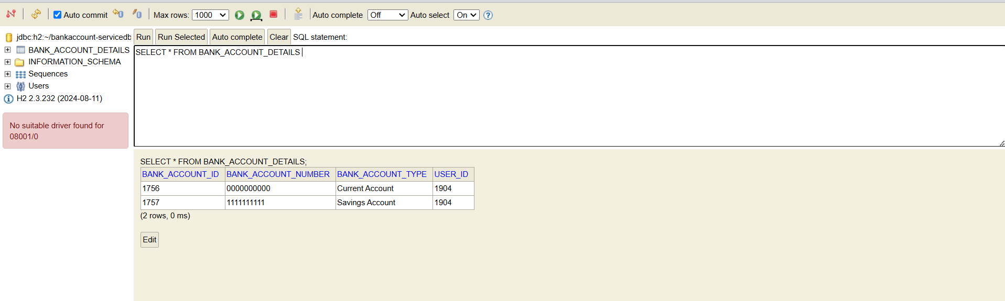

* **Get all the users details and bank account details of all the users**

**url: http://localhost:8085/user**

**method: GET**

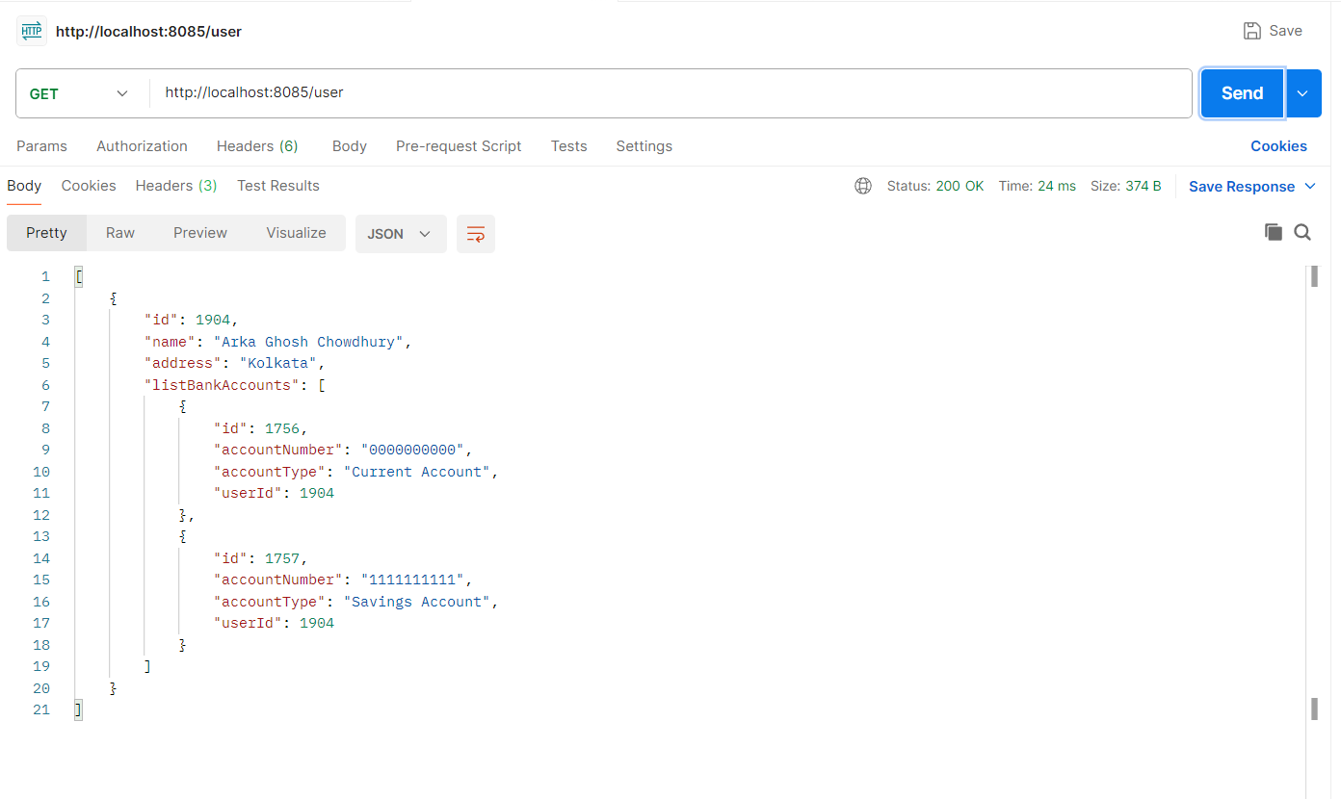

**Tables:**

* **USERS**

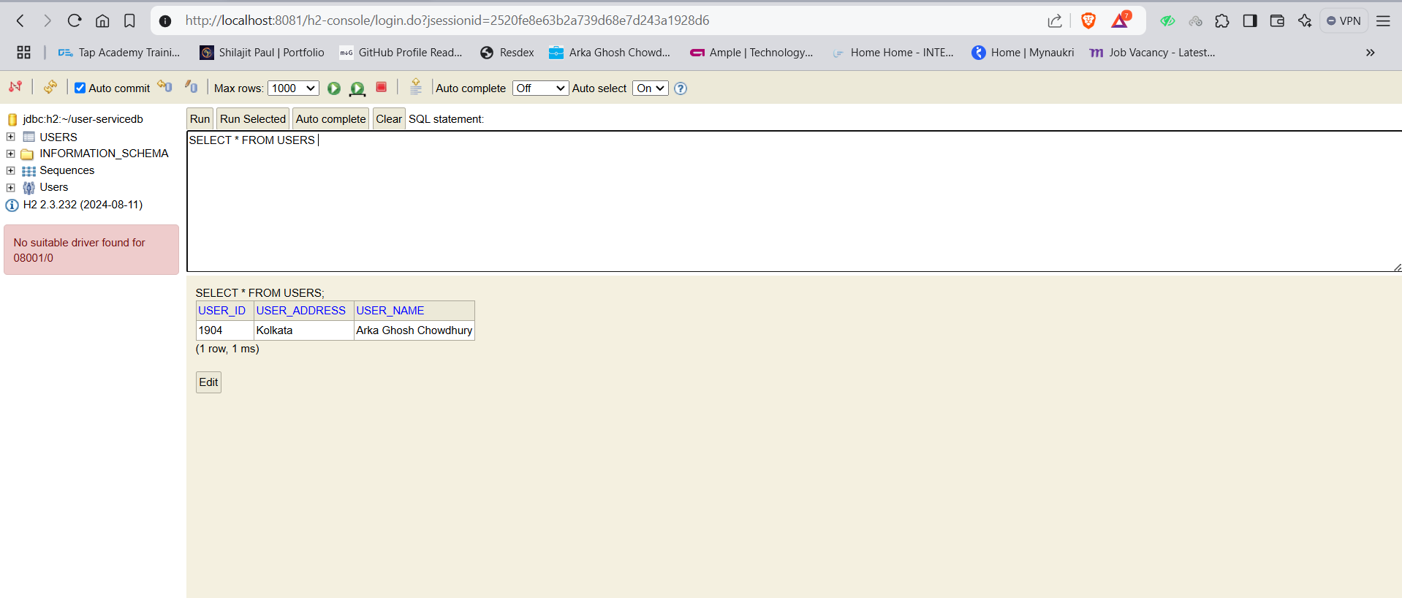

* **BANK_ACCOUNT_DEATILS**

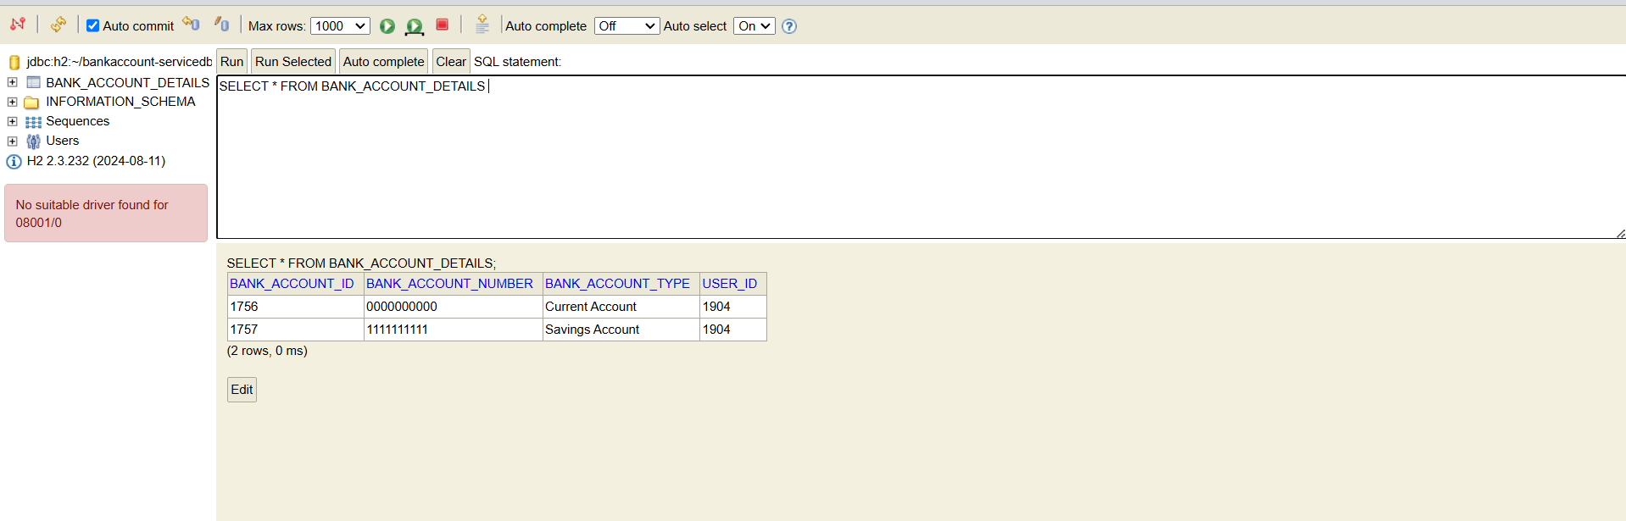

* **Get all the details of the particular user and also get the bank account details of that user**

**url: http://localhost:8085/user/1904**

**method: GET**

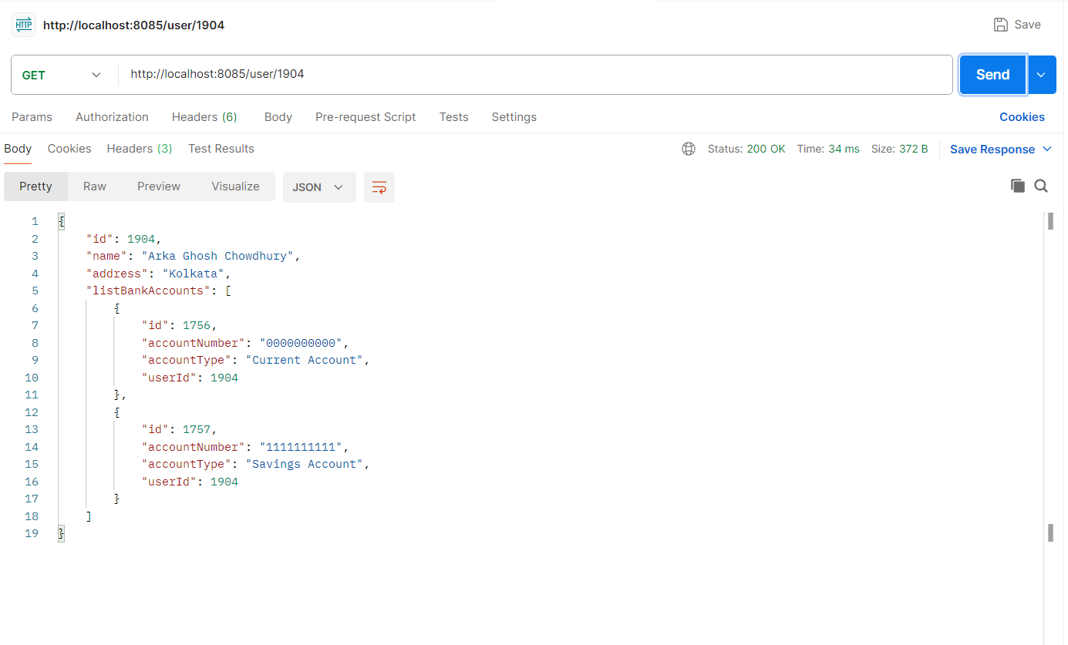

**Tables:**

* **USERS**

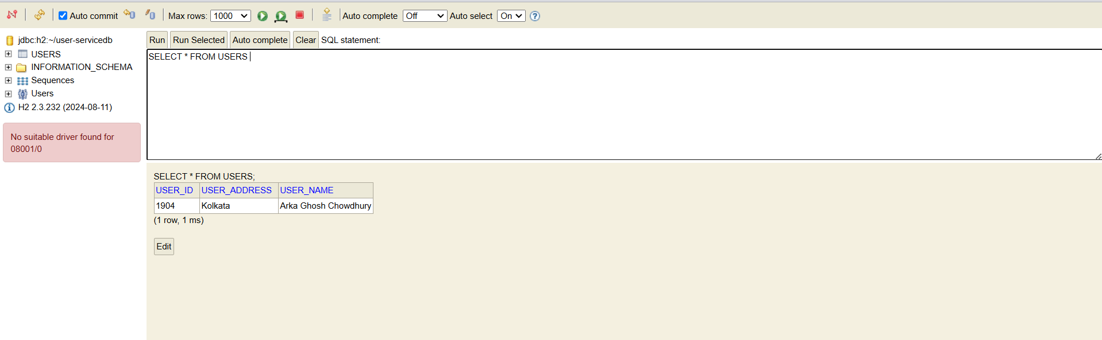

* **BANK_ACCOUNT_DETAILS**

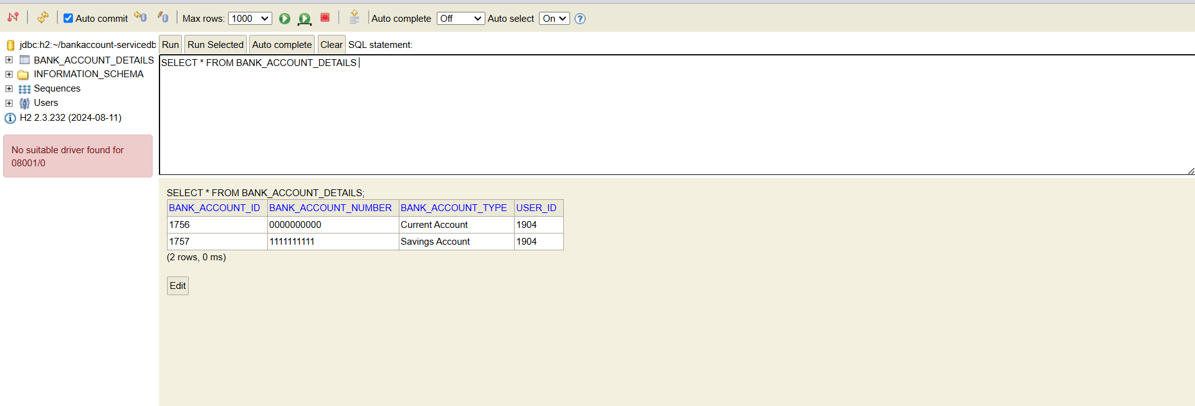

* **Update users details along with particular bank account details of that particular user**

**url: http://localhost:8085/user/1904/bank/1756**

**method: PUT**

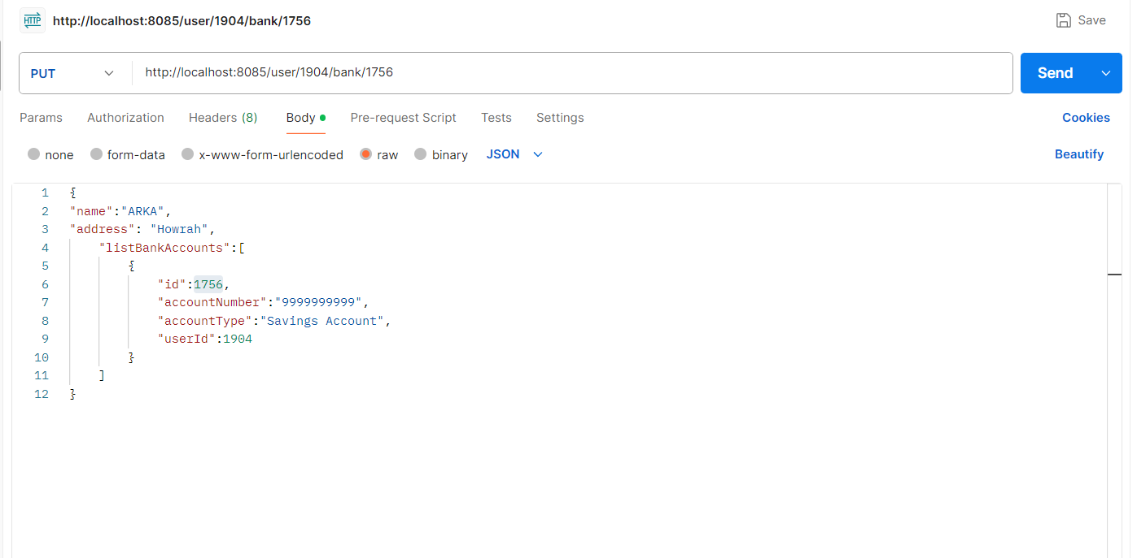

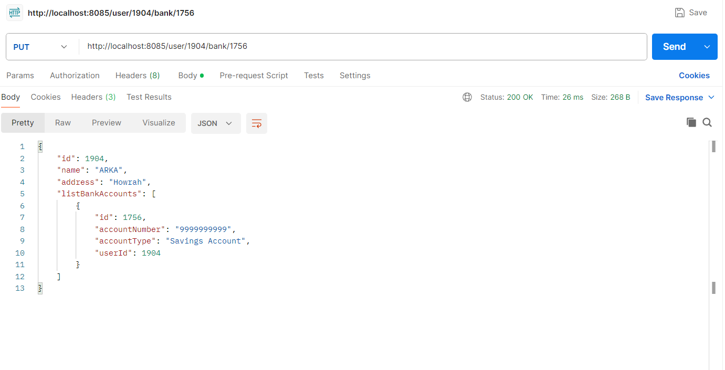

**Tables:**

* 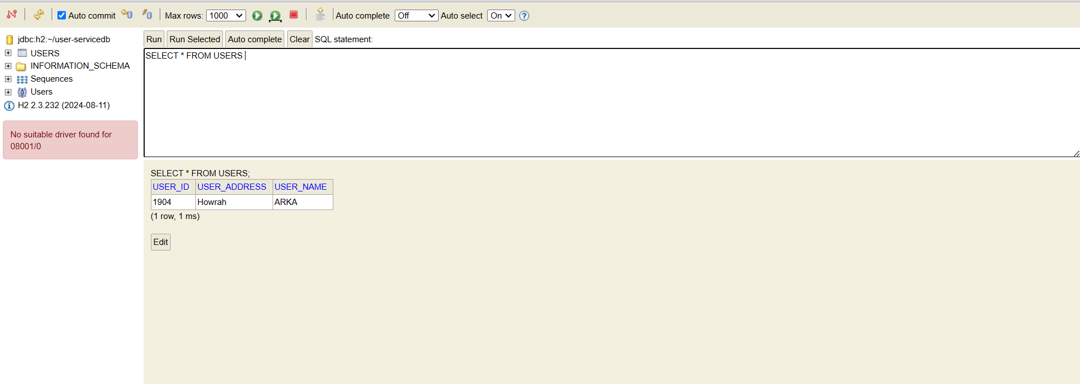**USERS**
* **BANK_ACCOUNT_DETAILS**

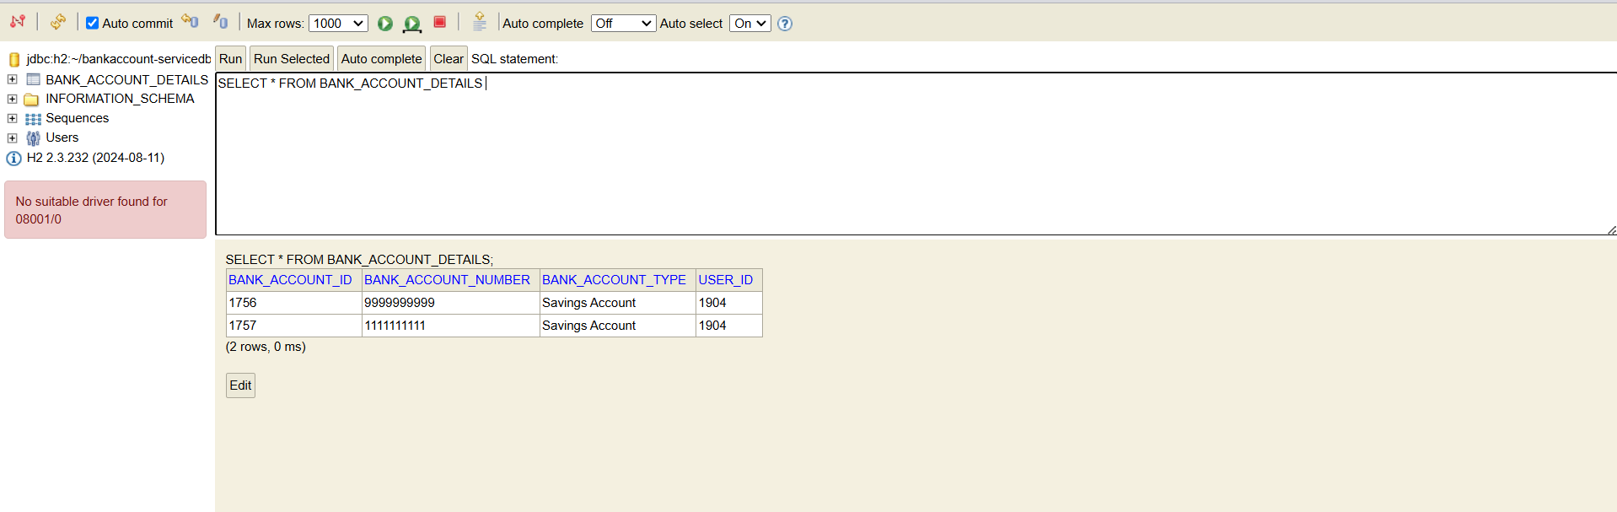

* **Delete user details and also delete the all bank account details of that particular user**

**url: http://localhost:8085/user/1904**

**method: DELETE**

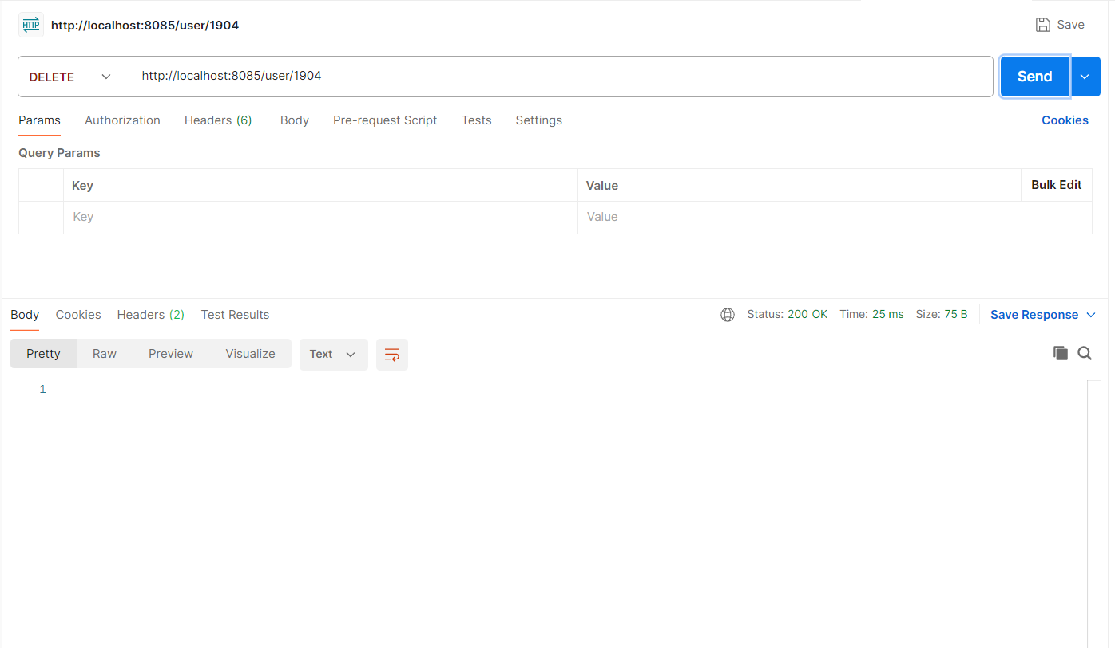

**Tables:**

* **USERS**

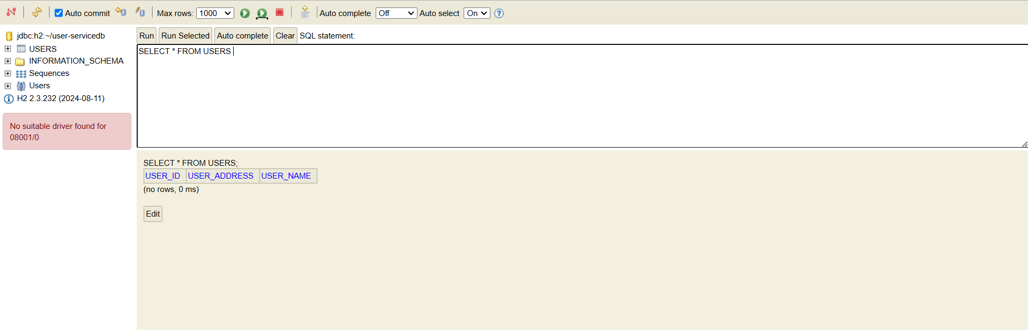

* **BANK_ACCOUNT_DETAILS**

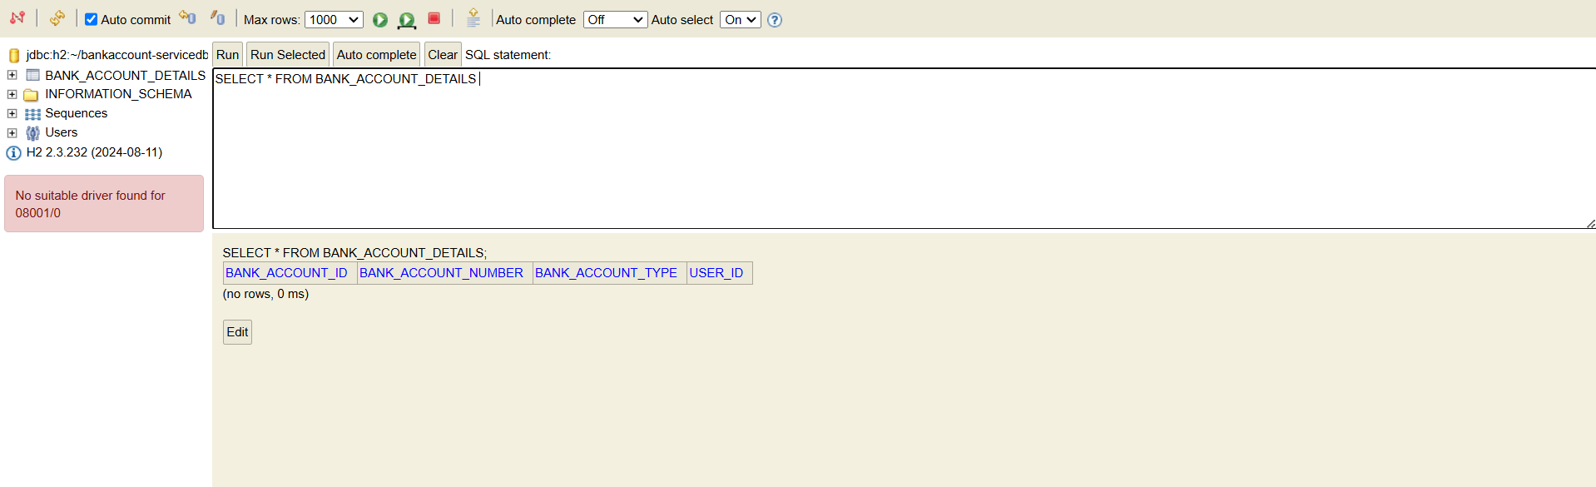

* **Create bank account details of the particular user**

**url: http://localhost:8085/bank**

**method: POST**

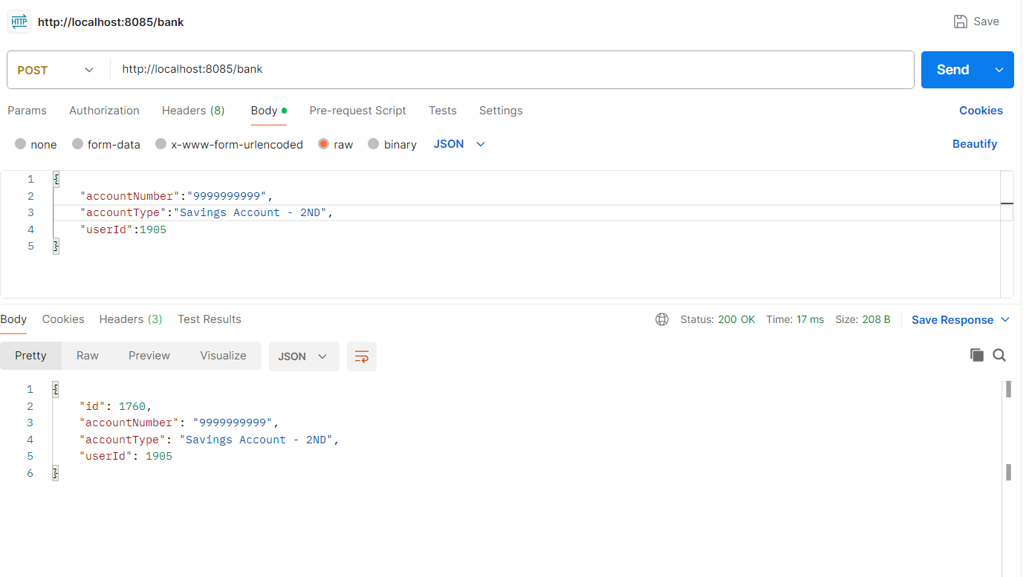

**Tables:**

* **BANK_ACCOUNT_DETAILS**

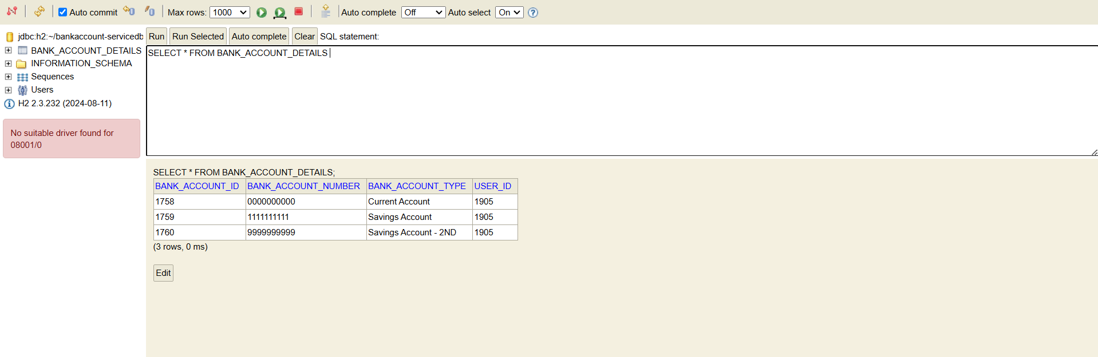

* **Get all the bank account details**

**url: http://localhost:8085/bank**

**method: GET**

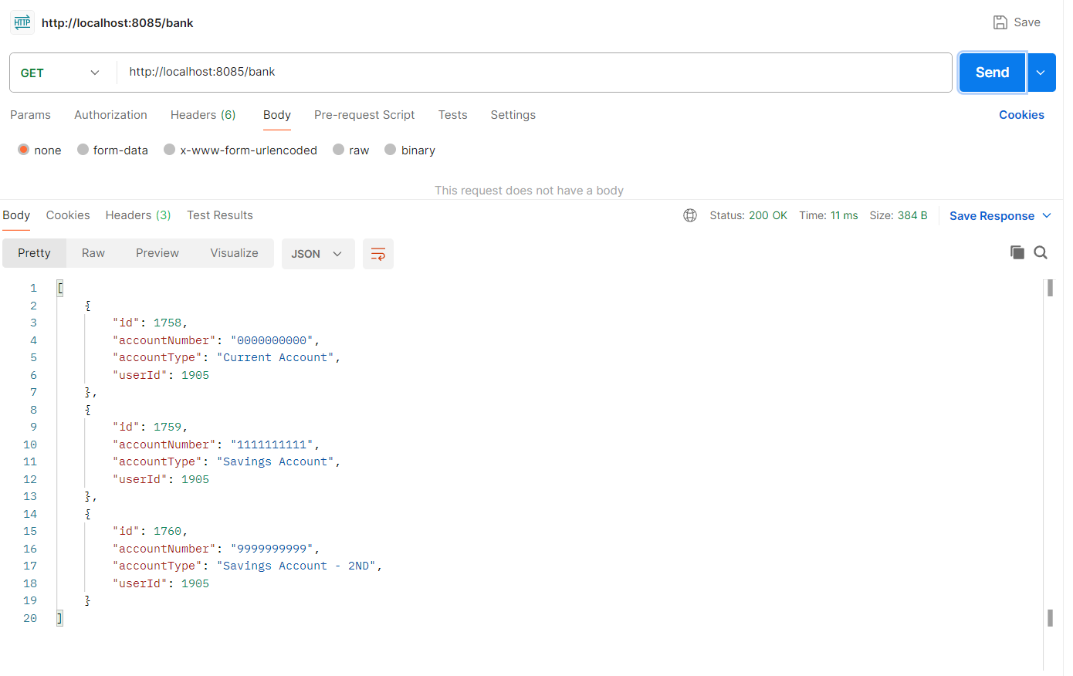

**Tables:**

* **BANK_ACCOUNT_DETAILS**

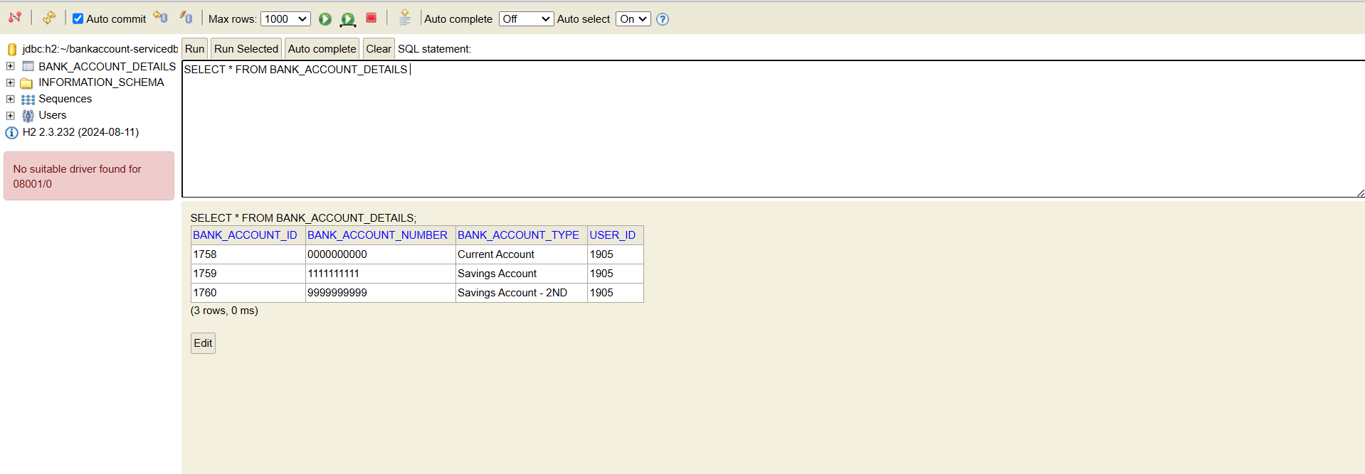

* **Get all the bank account details with respect to bank account id**

**url: http://localhost:8085/bank/1758**

**method: GET**

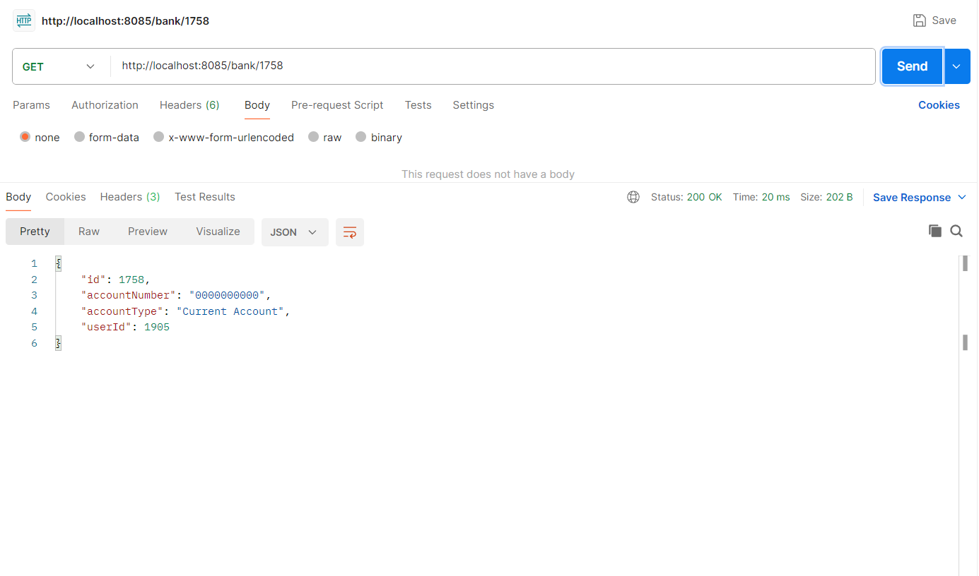

**Tables:**

* **BANK_ACCOUNT_DETAILS**

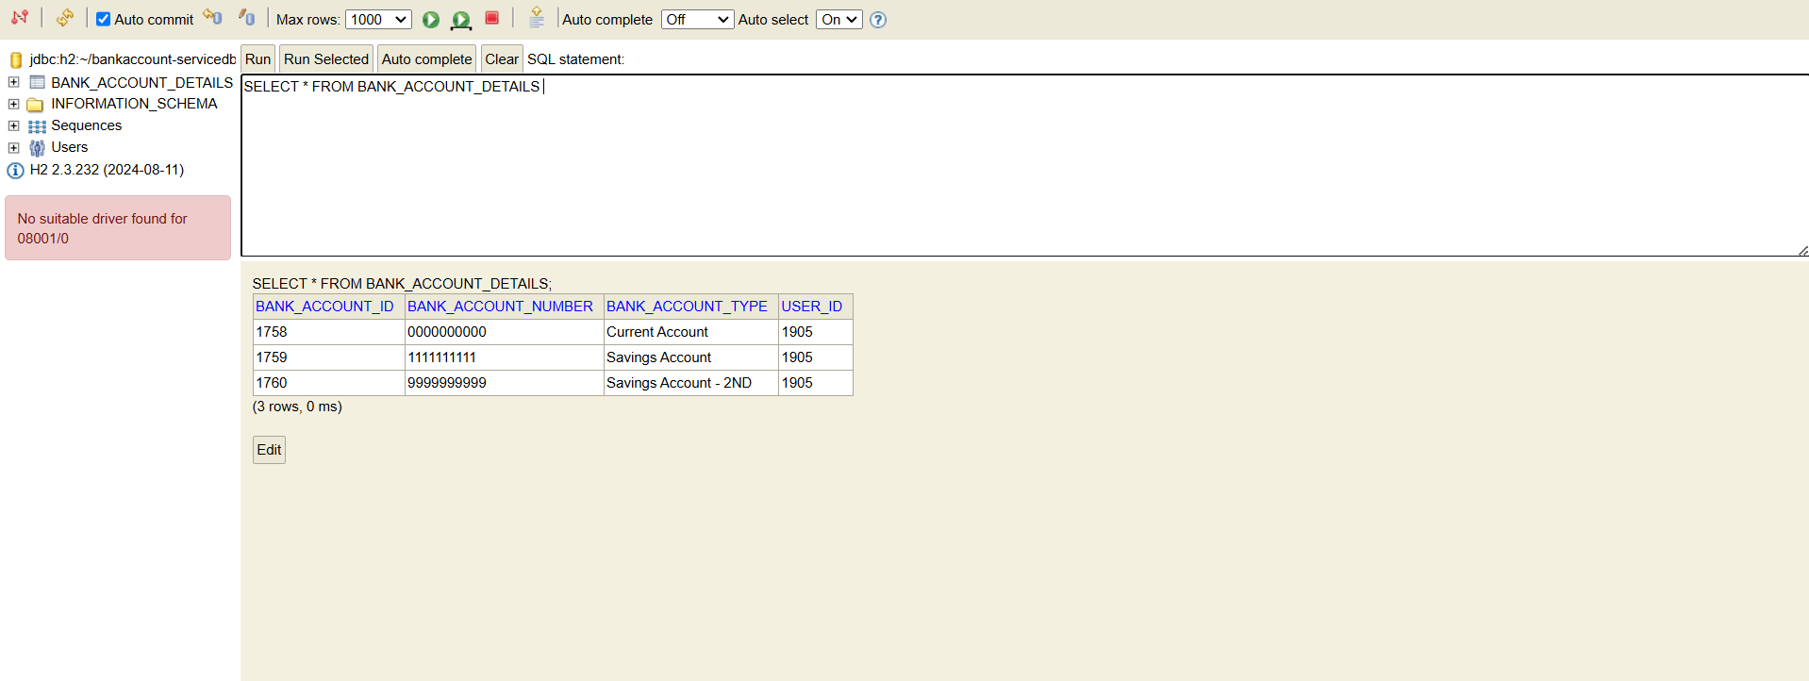

* **Update the bank account details with respect to bank account id**

**url: http://localhost:8085/bank/1758**

**method: PUT**

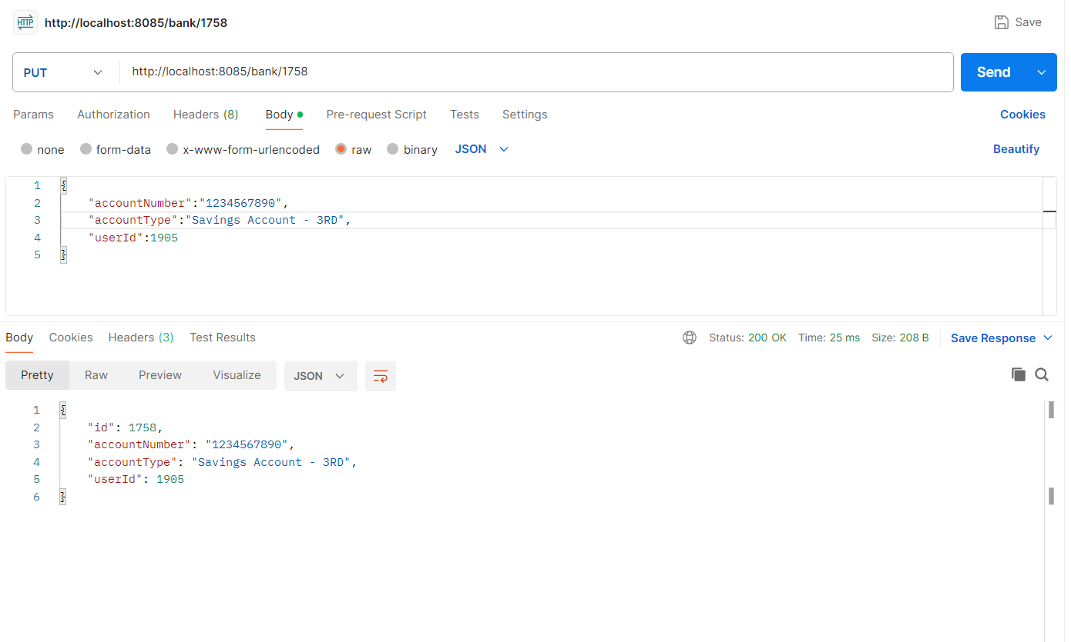

**Tables:**

* **BANK_ACCOUNT _DETAILS**

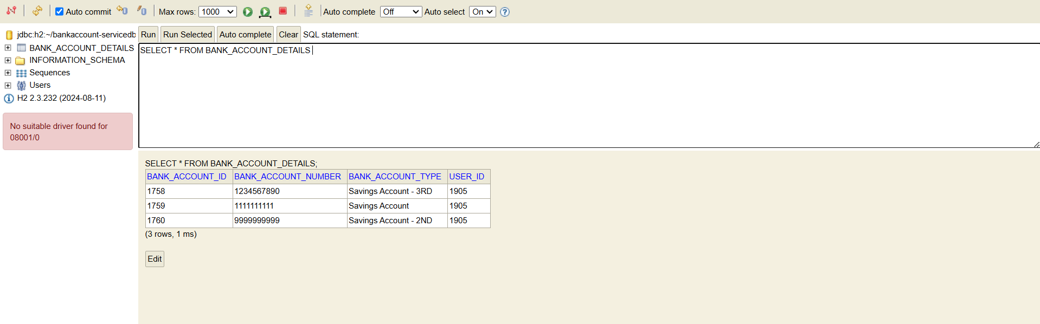

* **Delete bank account details with respect to bank account id**

**url: http://localhost:8085/bank/1758**

**method: DELETE**

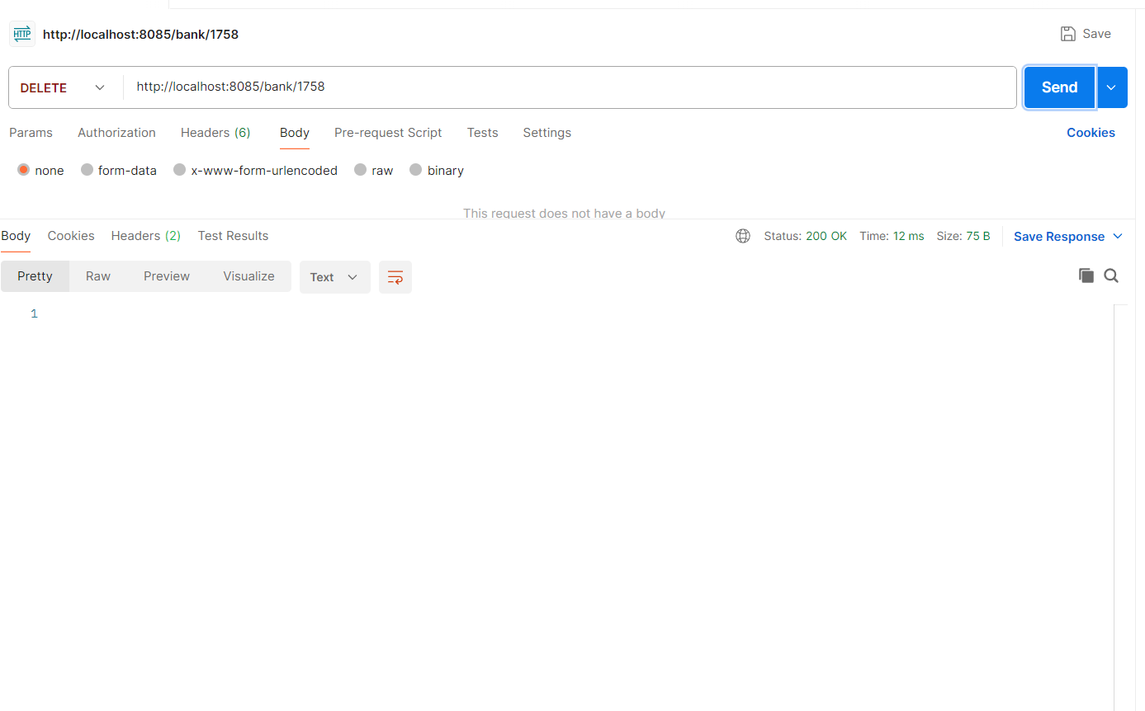

**Tables:**

* 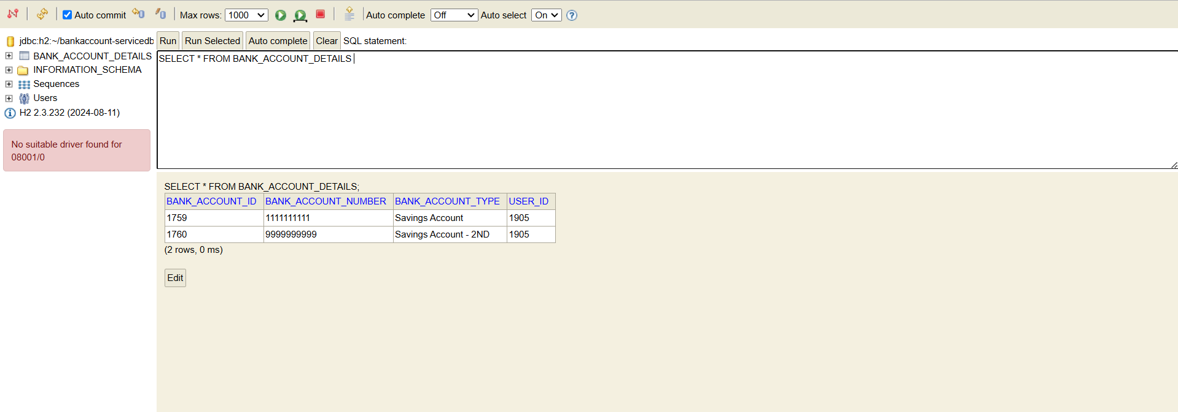**BANK_ACCOUNT_DETAILS**
* 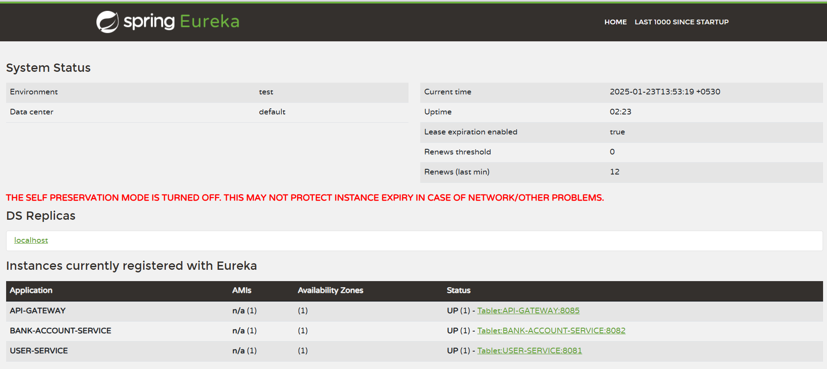**Eureka Service – Service Registry**